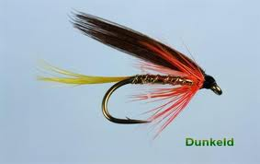
THE RIVER TAY
OPENING DAY GATHERING at DUNKELD
Tuesday 15th January 2013- 9.30am
THE HILTON, DUNKELD HOUSE HOTEL

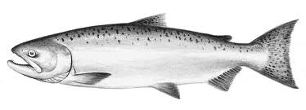
Join us to the celebrate Opening of the Salmon Fishing Season In association with
THE TAY FOUNDATION, DUNKELD AND BIRNAM
ANGLING AND TOURIST ASSOCIATIONS & PERTH CHAMBER OF COMMERCE

Community Reception - From 08:45am – 10.00am ~ ALL ARE WELCOME at this Event in the Garden Room, Hilton Dunkeld & the Opening with Pipes & Music at the Riverbank

Business Breakfast– 8.00am for 8.30am - £15 per person or tables of up to 10 guests can be booked - Tickets to the business breakfast are limited and must booked in advance.

To book for Breakfast contact: Hilton Dunkeld House Hotel. (Wendy Wisher)) Dunkeld. Perthshire. PH8 0HX Phone: 01350 728369/338- (wendy.wisher@hilton.com

For more information on Opening Day please contact the River Tay Offices on 01738-583733 or Mob: 07831 -131313

